Pehuensat, Argentina Satellite

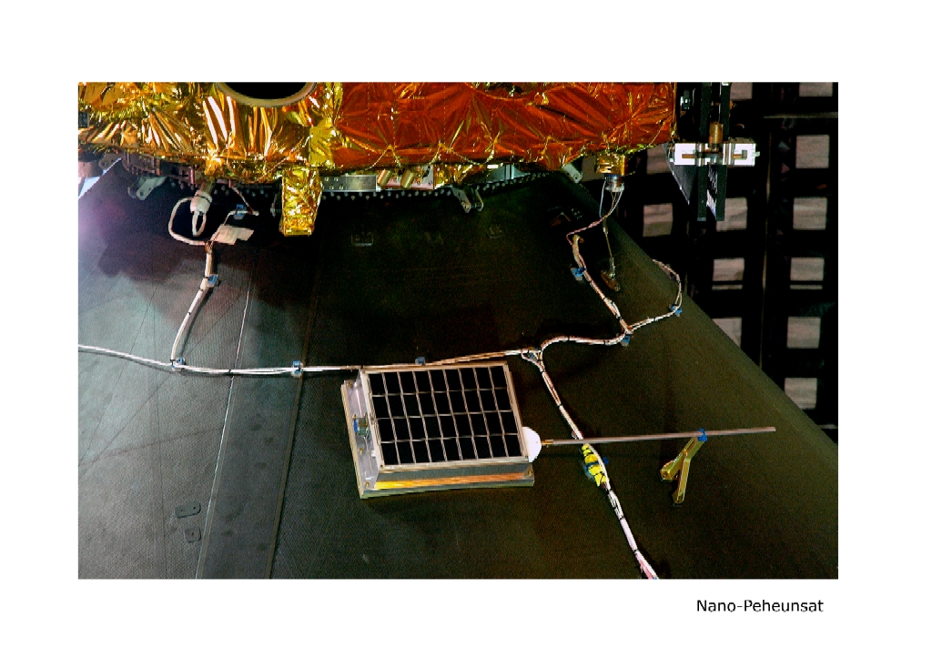
( pronounced as pea-when-sat )

Launched from India on 01/10/2007
Why the name Pehuensat ?

Pehuen or araucaria is a very special tree, it only grows on the south Andes mountains in a small region of lakes and high peaks. A branch of native indians named 'Mapuches' has the fruit of this tree as their main source of sustent thru Pehuen seeds (pine cones).
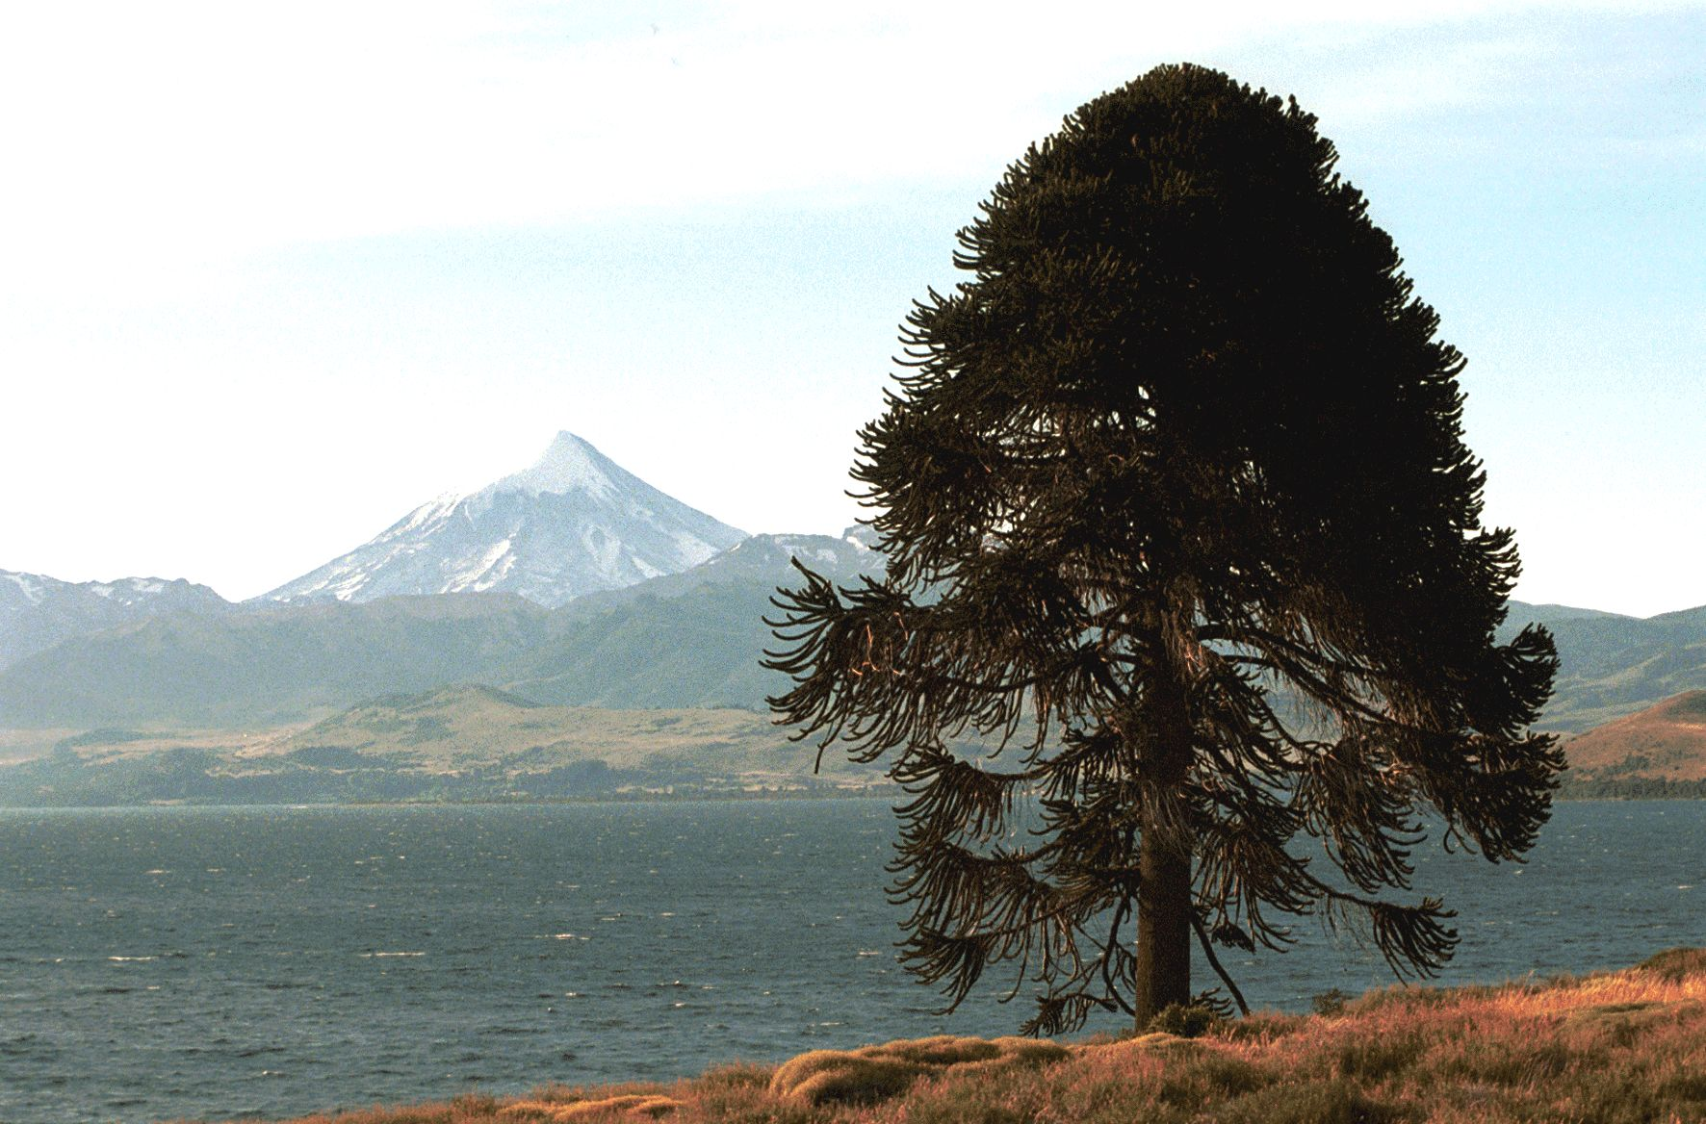

Under his impressive foliage that renders an inviting shadow along with his broad root that provides shelter against strong mountains winds, Indian group known as mapuches, meet offering to their gods sheep sacrifices involving meat, blood and smoke, hanging presents from tree branches as thanks and devotion.

Follows a tale, known in all Patagonia (south part of Argentina between the Andes and Atlantic coast) passed by word thru generations in mapuche language.

The Pehuen miracle

Since memory exists, Unechen (mapuche God) created pehuen and planted in all earth forests, but initially the inhabitants did not eat the seeds, that remained on the ground producing more and more trees that deteriorate given humidity and warmth of summer session. Pehuenches (name of the indians on the area) considered pehuen as a holy tree but didn't eat the pehuen pine fruits due they where hard and considered poisonous.
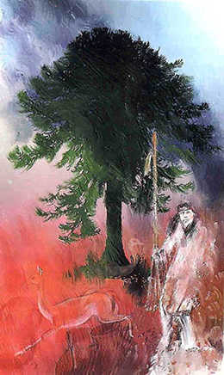

Long before the 'huinka' (Spanish invaders) came with weapons, horses and their army, there was a very crude winter, the tribe already without food or reserves was being decimated by cold and hunger, rivers had frozen, 'huemul' (a sheep like wild animal) disappeared as well as the 'choike' (patagonian ostrich) and the 'guanaco' (small camel without hump). Also all birds emigrated scared away by tremendous cold.

Earth seems to squeeze under cold and snow, even young people still resisted, older and kids seems to be condemned to a horrible death. Unechen seems to unheard pledges, perhaps himself was asleep on his bed of warm furs.

Under this critical situation, the chief of the tribe decide to take a desperate decision. Send to the four winds directions and for different trails his more skillful and strong warriors to go as far as necessary, with the imperative request to bring back food, any seed, fruit, plant or animal.

There went the brave soldiers, enthusiastic and decided, but days passed one after another and soldiers returned with empty hands and in worst conditions that they went. Till only one left, Nehuen, on him the chief placed his maximum hope. His name 'Nehuen' that means 'skillful hunter'.

Days passed and hope vanished more and more. Hungry, anguish and impotence evolved into child cries and parents desperation.
Finally, they saw far away a man walking with difficulties on the slopped and frozen mountain side, hanging on his back his guanaco leather bag full of pehuen seeds/pine cones that let down open on the tribe chief's feet.

An ancient 'machi' (tribe quack/wizard) woman intrigued asked: Why you bring your bag loaded with fruits of the holy tree, the pehuen ?. You know we can't calm our hunger with that ?.

-Your words are truth, but you are wrong. What I brought are actually Pehuen pine cones, but these will save everybody, answer the boy without vacillation.
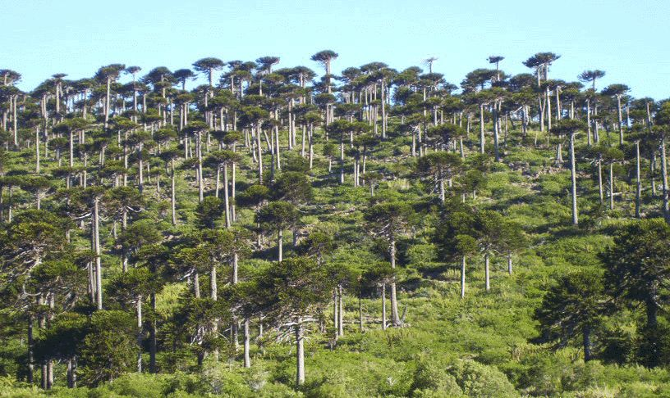

Don't blaspheme ! said the tribe chief, Unechen will punish you for this !

-Let me explain and then you'll decide. After walking and walking during several days without finding anything to alleviate your needs, I was coming back by the waterfall trail, and unknown old man showed from who knows where and started walking besides me.

- What are you searching in my mountains, son ? . He asked me.

- I am searching for food for my tribe, they are starving -I answered- but I have not founded anything.

Snow and ice are everywhere, soon they will cover us also.

- Nevertheless with that much pehuen pine cones that are all over the ground, you shouldn't be starving. Why are you disdaining a food so extraordinary ?

- But those are fruits of the holy tree, ancient man - I answered, a little embarrassed - They are so hard, and the machi say they are poisonous.

- You believe that a gift from Unechen could be harmful to your kids ?. No boy, no; go and speak with your tribe and tell them is a delicious food. Just boil them to make them tender, then toast them and you will enjoy a delicious and nutritious food. Each pine cone is enough to feed a man for several days, and you can keep them during winter burying them in holes on tender soil, you will have enough nutritional food despite hunting become scarce.
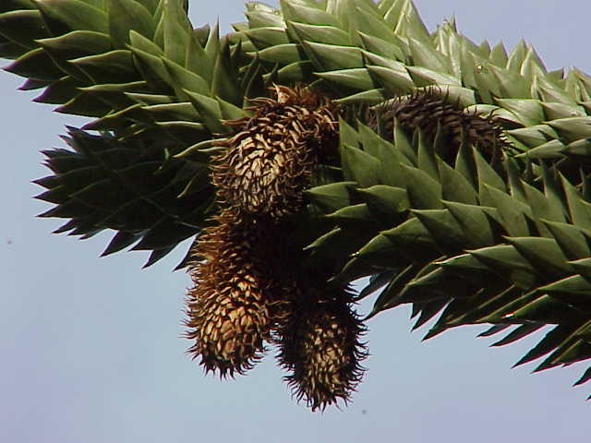
And after saying these words, the stranger vanished same way as he comes, I started to collect the Pehuen fruits to bring them to you.

The tribe council immediately called for an assembly of the older and debate about the news brought by the young hunter, deciding that the ancient man that intercepted Nehuen was no other than the real god Unechen in person, so they order all women that boiled and then toasted the pine fruits brought by the warrior.

Since then, tells the legend, there were no more starving nor lack of food, given pehuenches learned many ways of prepare the fruits of the pehuen. So the sacred tree became the main source of food for the pehuenches, that every day pray at the break of dawn with a pine fruit or a branch from the Pehuen in their hands, saying:

- To you, Father, for not to allow us to die for starving.
- To you, Father, that showed us how to share our food with others.
- To you, Unechen, we beg that never let the Pehuen die, whose branches extend as open arms to protect us.

Source: Tales and myths of the Patagonia.

Translated by lu7abf, Pedro Converso lu7abf@amsat.org.ar from
http://www.temakel.com/milagrodelpehen.htm

